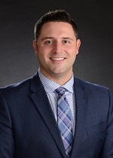
Paul G. King - Mr. King is an associate with the firm whose practice is focused on the areas of labor and employment law in the public and private sector, education law, and litigation. Mr. King has represented clients in collective bargaining negotiations, before administrative bodies, and in federal and state courts. Prior to joining the firm, Mr. King served as a Senior Law Clerk to the Justices of the Massachusetts Superior Court, where he directly assisted judges in all phases of civil and criminal litigation.

Mr. King graduated with the highest distinction from Suffolk University in 2013 with a Bachelor of Science degree in Government. He received his Juris Doctor in 2016 from Suffolk University Law School, where he served as an Article Editor of the Suffolk University Law Review and received the Fuchs Labor Law Memorial Prize for his academic achievements in the field of labor law.

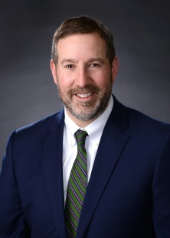
Michael J. Maccaro – Mr. Maccaro is a partner at the firm and represents both private and public sector clients in a variety of labor and employment matters. Mr. Maccaro’s labor law practice includes representing employers in contract negotiation, collective bargaining matters, grievance administration and arbitration, and in proceedings before the Massachusetts Department of Labor Relations and the National Labor Relations Board. Mr. Maccaro’s employment law practice includes defending employers in a wide range of workplace claims, including claims of employment discrimination, retaliation, and wrongful discharge before the Massachusetts Commission Against Discrimination, and other enforcement agencies. Mr. Maccaro has also successfully represented clients before the Division of Unemployment Assistance, the Civil Service Commission, the Massachusetts Superior Court, and the Massachusetts Appeals Court. Mr. Maccaro routinely conducts and counsel employers in workplace investigations.

Prior to joining MHTL, Mr. Maccaro served as an Associate General Counsel for a large public sector labor union, where he litigated over one hundred arbitration cases. Following law school, Mr. Maccaro served as a Law Clerk to the Justices of the Superior Court. Mr. Maccaro has served as an Adjunct Professor at Massachusetts School of Law where he taught legal writing and oral advocacy. Mr. Maccaro regularly speaks to employers on matters such as collective bargaining obligations, employment practices, and drafting of workplace policies. Mr. Maccaro serves on the Executive Board of the Labor and Employment Relations Association (LERA). He is the 2019 recipient of the Cushing-Gavin Award for excellence in providing management labor relations legal counsel. Attorney Maccaro is also involved with training new lawyers on arbitration best practices.

Mr. Maccaro is a member of the bar of Massachusetts and is admitted before the federal District Court in Massachusetts. Mr. Maccaro graduated from Bates College with a Bachelor of Science degree in Biological Chemistry. He received his law degree from Northeastern University.

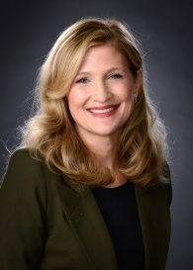
Kathryn M. Murphy - Ms. Murphy is a partner at the firm and practices in labor and employment law with a focus on representing clients in employment matters, conducting trainings and investigations, drafting employment documents, and providing day-to-day general advice. Prior to joining the firm, Ms. Murphy served three years with the Office of the Attorney General of the Commonwealth of Massachusetts, including two years as an Assistant Attorney in the Fair Labor Division where she handled criminal and administrative enforcement of labor laws including wage and hour, public construction, health and safety, child labor, unemployment taxation, and workers’ compensation insurance. In 2011 Ms. Murphy obtained her certification as a Senior Professional in Human Resources (SPHR). Ms. Murphy graduated cum laude from the Suffolk University Law School where she served as an Editor on the International Law Review. Before practicing law, Ms. Murphy practiced as a Certified Public Accountant (CPA).

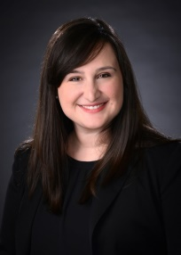
Sarah Spatafore – Ms. Spatafore was promoted to partner in 2020. Her practices are primarily in the labor and employment area, representing both public and private clients. Ms. Spatafore also handles education issues on behalf of public school districts, charter schools, and private schools throughout Massachusetts. Ms. Spatafore has represented clients before a number of courts and administrative tribunals at both the state and federal level, including representing clients in trials at both the state and federal level. Ms. Spatafore also regularly represents both public and private employers on issues relating to collective bargaining, including contract negotiations, grievance hearings, and arbitrations. She regularly conducts seminars and training programs on unlawful harassment, preventing discrimination, and a variety of other labor and employment issues. Ms. Spatafore has completed all the Massachusetts Commission Against Discrimination-certified “Train-the-Trainer” courses. Additionally, Ms. Spatafore conducts internal investigations for employers on a broad range of issues, including claims of discrimination and harassment.

After graduating from Bates College, Ms. Spatafore spent a year working on a presidential campaign and then served as a presidential appointee at the National Aeronautics and Space Administration in Washington, D.C. She received her Juris Doctor, with Honors, from Boston College Law School in 2012. Prior to matriculating with the firm, Ms. Spatafore worked for a presidential campaign as a law clerk and was sent to a targeted swing state to serve as the Election Day Operations Director for the general election.

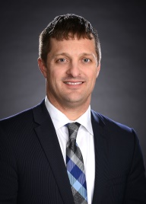
Kier Wachterhauser - Mr. Wachterhauser is a partner at MHTL. Mr. Wachterhauser represents private and public sector clients in all areas of labor and employment law and maintains a general litigation practice. Mr. Wachterhauser regularly counsels clients on employment matters, including wage and hour, leave entitlements, and discrimination and harassment matters, as well as the drafting of employment policies and contracts, and represents clients in employment-related litigation before state and federal courts and administrative bodies, such as the Massachusetts Commission Against Discrimination and the Equal Employment Opportunity Commission. Mr. Wachterhauser also maintains an extensive labor practice, representing public and private clients in the collective bargaining process, arbitration hearings, and proceedings in front of administrative agencies such as the National Labor Relations Board, the Civil Service Commission, and the Department of Labor Relations. Mr. Wachterhauser’s clients include health care agencies, financial institutions, food service entities, local housing authorities and other State and local governmental entities.

Mr. Wachterhauser is a regular speaker at industry and trade groups, chambers of commerce, and other organizations on a wide range of labor and employment topics. Mr. Wachterhauser also conducts workplace training for organizations of all sizes.

Mr. Wachterhauser received his Juris Doctor from Boston University School of Law, where he served as the Editor-in-Chief of the Boston University Law Review. In law school, Mr. Wachterhauser was awarded the Faculty Award for Academic Accomplishment. Prior to attending law school, Mr. Wachterhauser spent several years working in the consulting field, providing guidance to administrators of hospitals and universities on a variety of business-related matters. Mr. Wachterhauser received a Masters of Arts degree from Northwestern University and graduated from Swarthmore College with honors.

